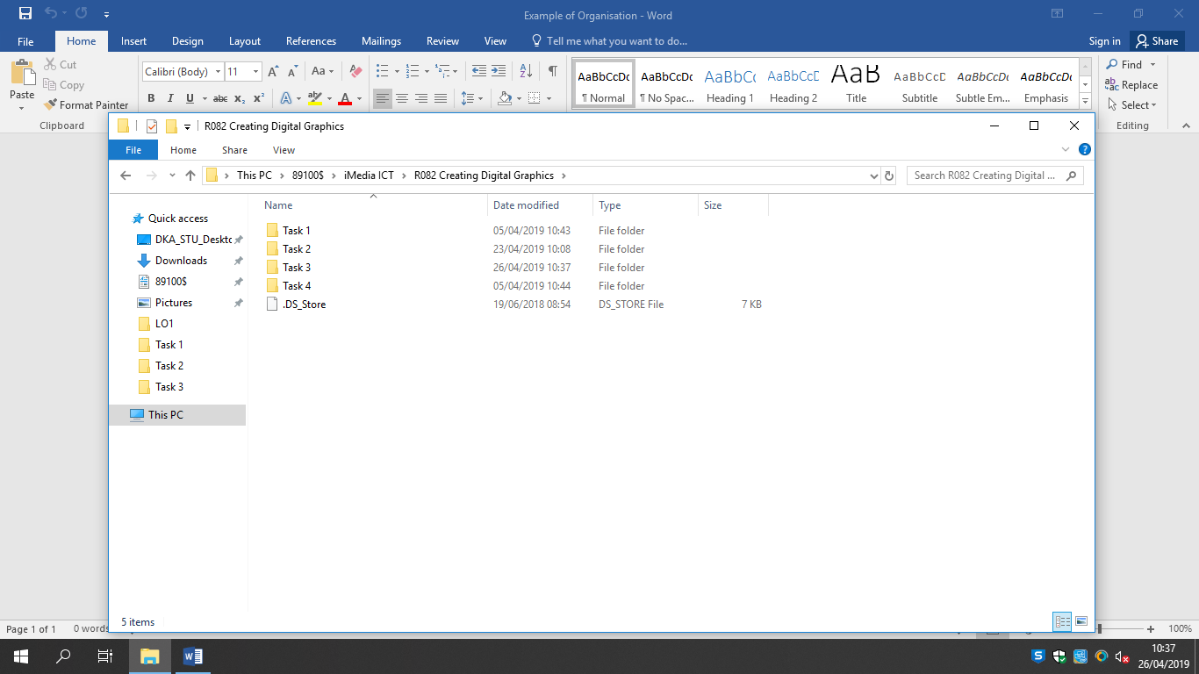

This screenshot shows that I’ve organised the different LO’s into different folders.

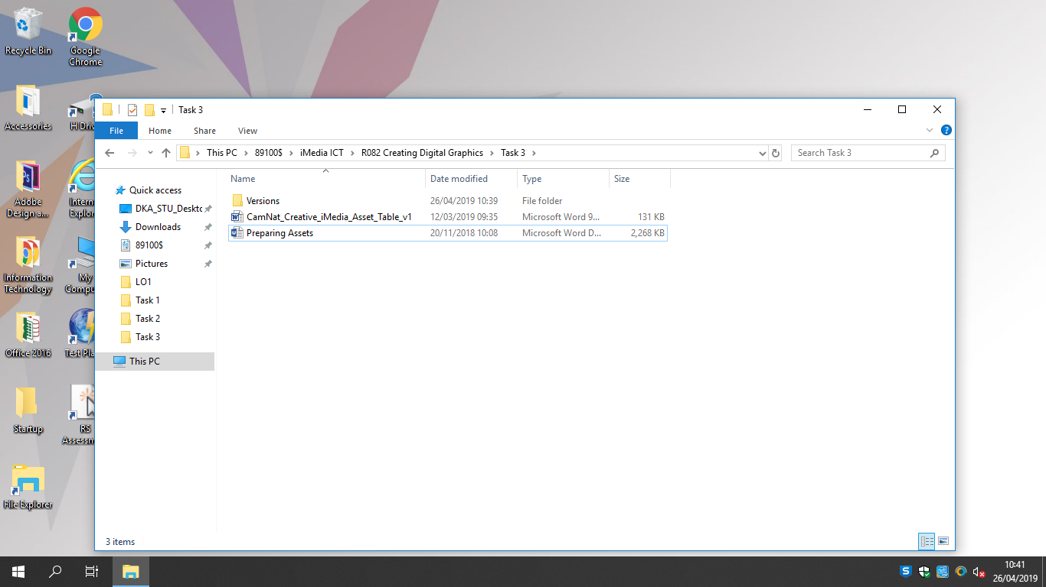

Another folder showing my versions

This is my LO3 folder and as you can see it has another folder inside that shows the different versions that I created for the TIMECHASERS game.

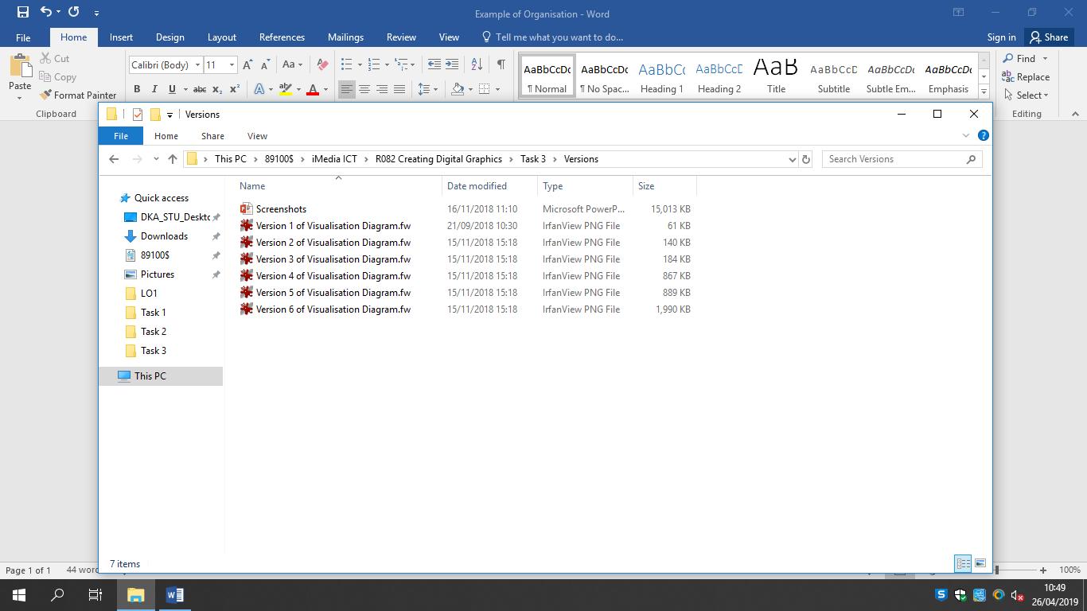

This is inside my ‘Versions’ folder and it shows the different version I made.